EXPERIMENT 2

Aim: To design a user interface prototype for a Mobile Station using Figma, focusing on connectivity and user convenience.
Procedure:
• Open Figma and create a new design file.
• Create a mobile frame using a suitable phone screen size.
• Design the Home Screen with network status, signal strength, and data usage.
• Add a Calls Screen with a dial pad, contacts, and recent calls.
• Create a Messages Screen for SMS and chats.
• Design an Internet Screen for browsing and internet access.
• Add a Settings Screen with Wi-Fi, mobile network, SIM management, and data usage.
• Use suitable icons, colors, buttons, and text to make the interface simple and user-friendly.
• Open the Prototype tab and connect the screens using clickable buttons and navigation links.
• Click Present to test the prototype and verify that navigation works correctly.
OUTPUT: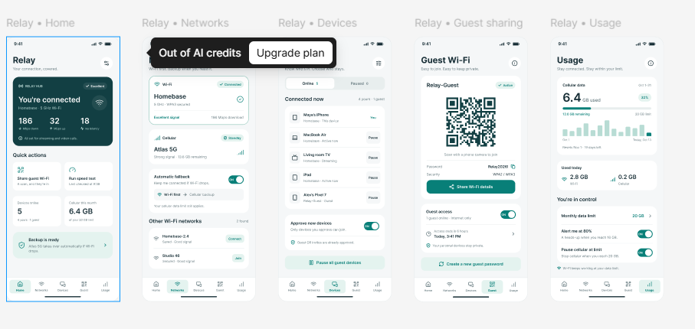
FIGMALINK: https://www.figma.com/design/ED1qcVpNfWi2Zuft4amJyZ/Untitled?node-id=0-1&t=8CISduiChR7iJkAE-1
RESULT:
A user-friendly Mobile Station interface prototype was designed using Figma. It provides easy access to calls, messages, internet, settings, and network connectivity information, improving connectivity and user convenience.

